**Date: 28/10/2020**

**Practical no 8**

**AIM**: Define a RESTful web service that accepts the details to be stored in a database and performs CRUD operation**.**

**Steps :-**

1. **Right click on Java DB** and then **click on Start Server** to start the server.

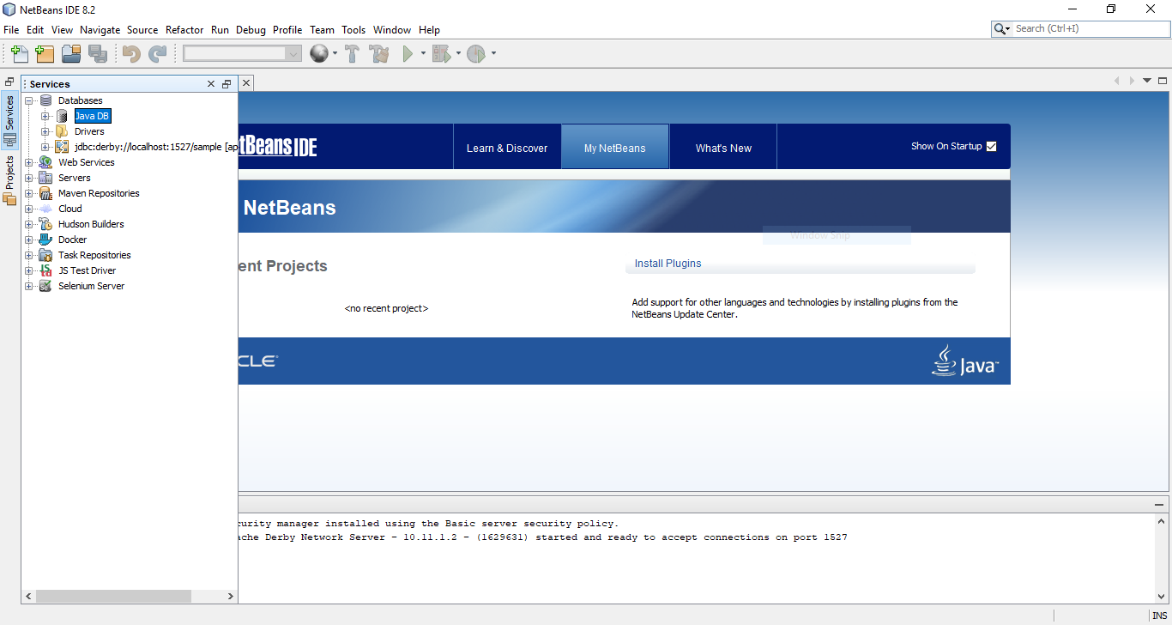

**2)** Now expand Java DB and **right click on sample** and then **click on connect** to connect the sample database with server.

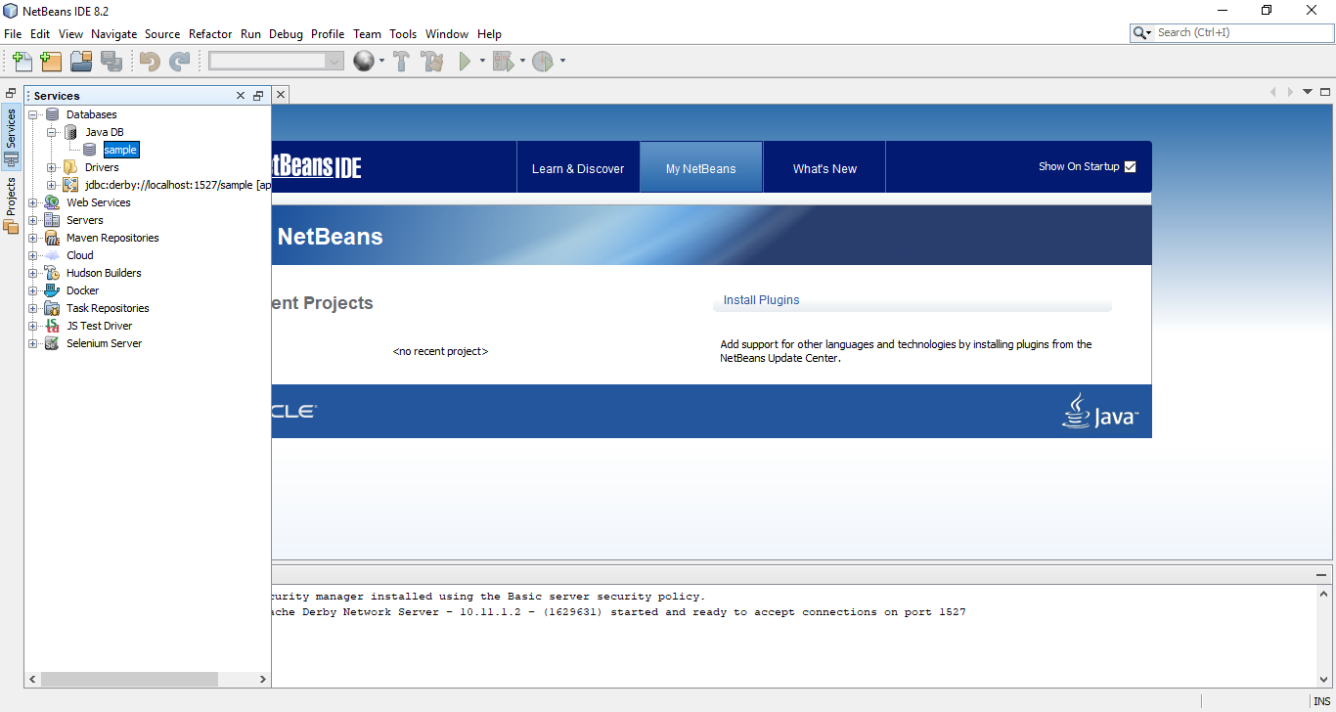

**3)** Now create a web application with the name **CRUD_Operation**. A window will open like following pic.

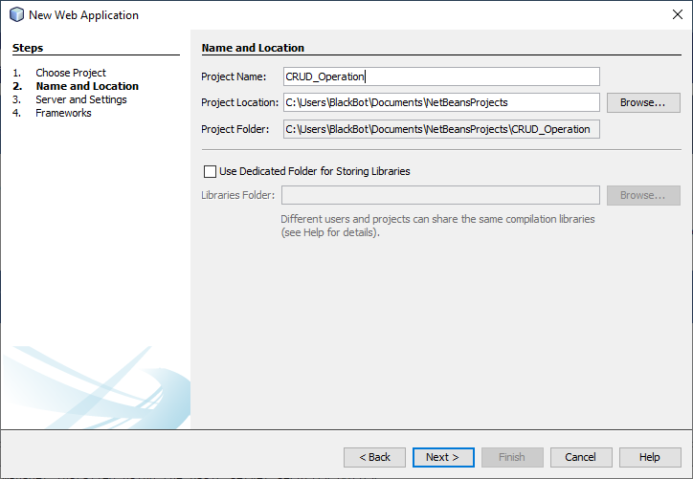

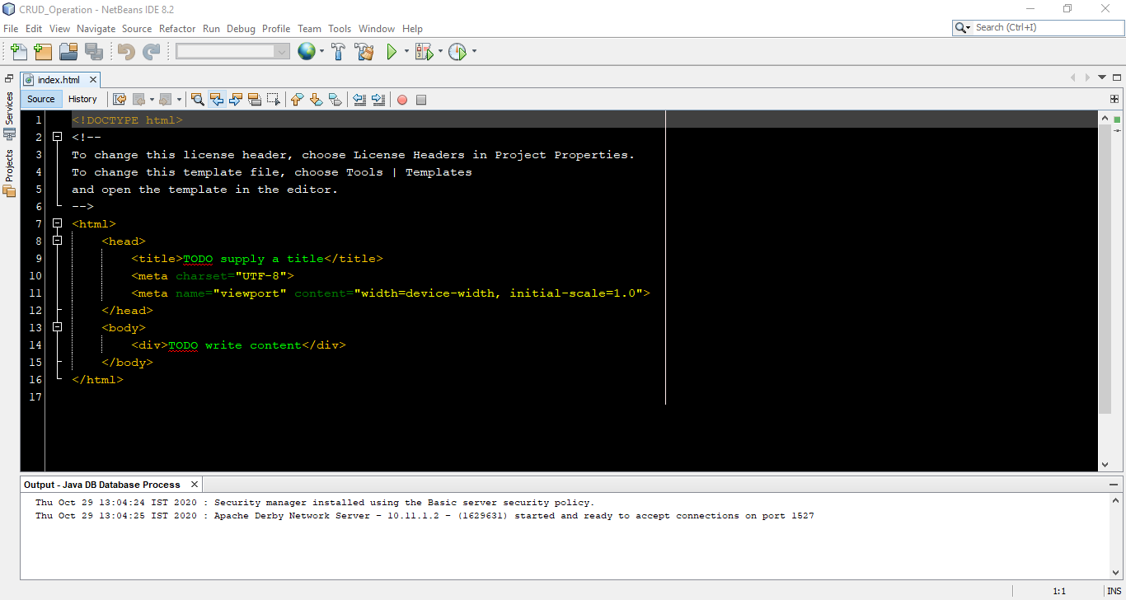

**4)** Create an entity class. **Right click on project name -> New -> Entity Class**.

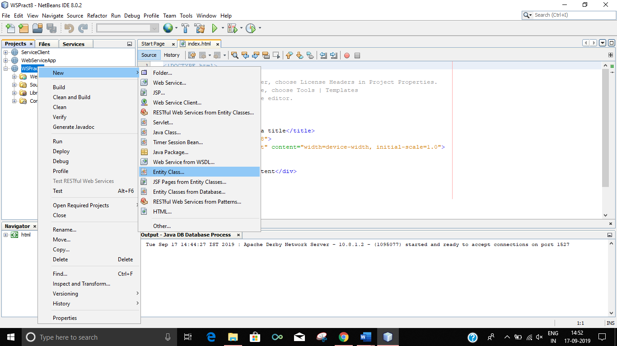

**5)** A window will appear like bellow pic. Enter following data and click on Next

**Class Name : students**

**Package name : CRUD_Operation**

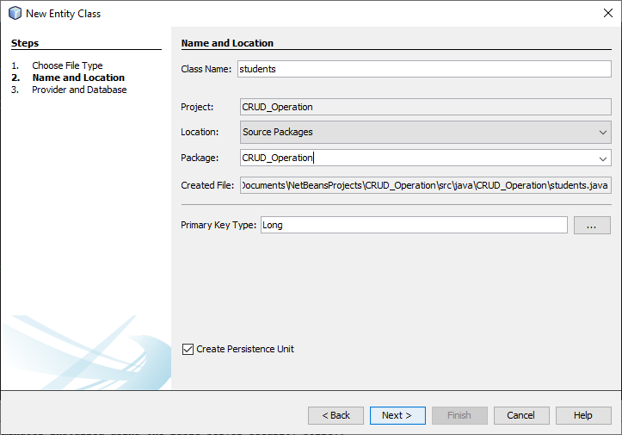 **6)** Click on Finish.

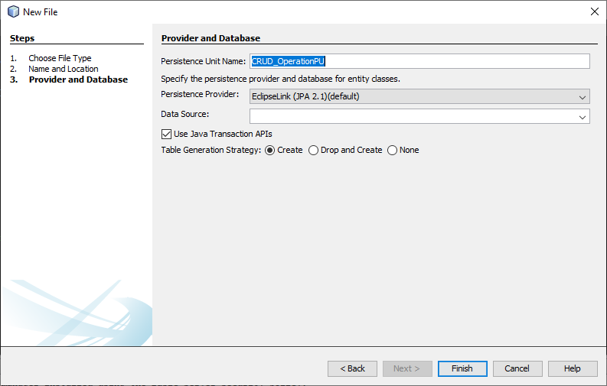

**7)** Right click on project name and create JSF Pages from Entity Classes.

**Right click on project name -> New -> JSF Pages from Entity Classes**

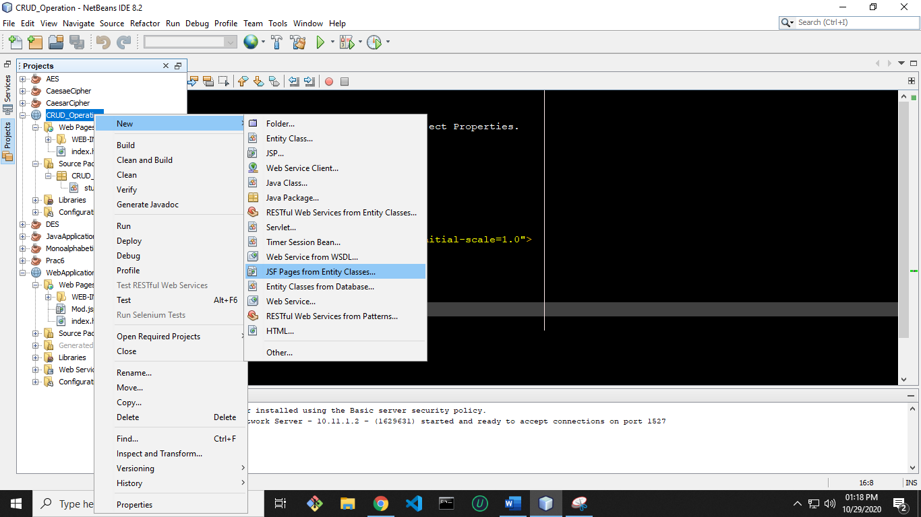

**8)** **Select wspract8.students** and **click on Add button and then Next button** on below.

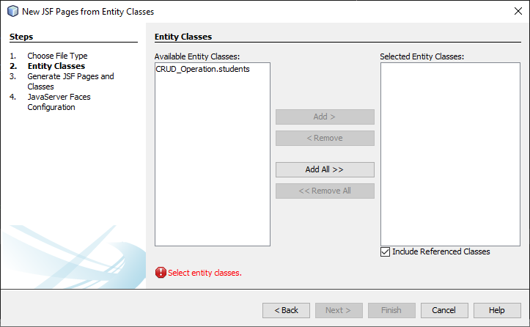

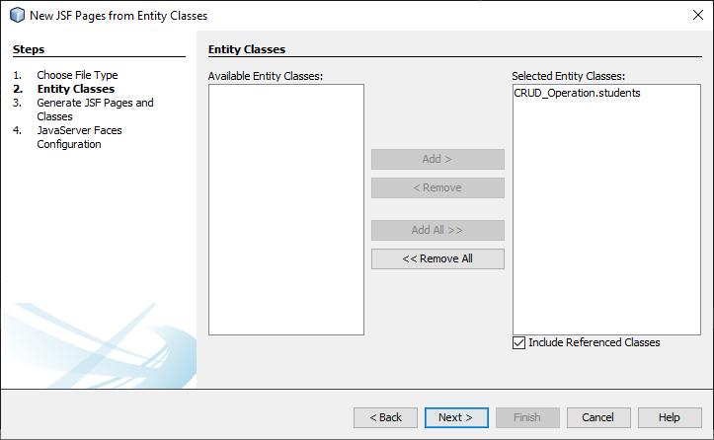

**9)**A window like below will appear on the screen. **Enter the data into that** **window as**

**entered in below pic** and **click on Next button**

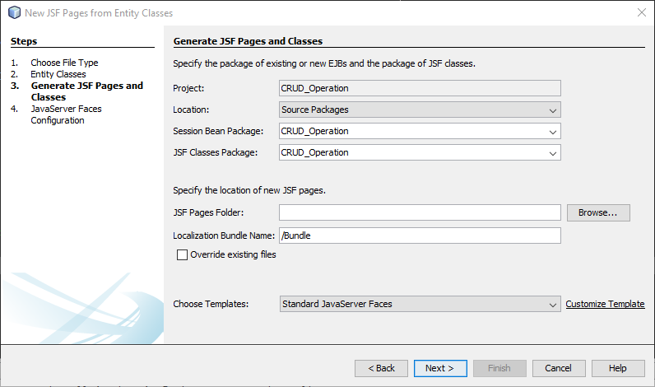

**10**)Now **click on Finish**

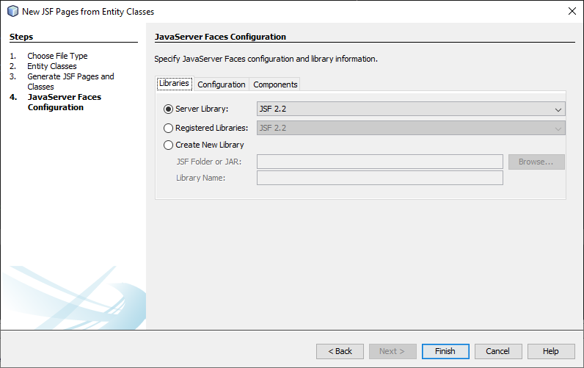

**11)** Right click on project name and create RESTful Web Services from Entity Classes.

**Right click on project name -> New -> RESTful Web Services from Entity Classes**

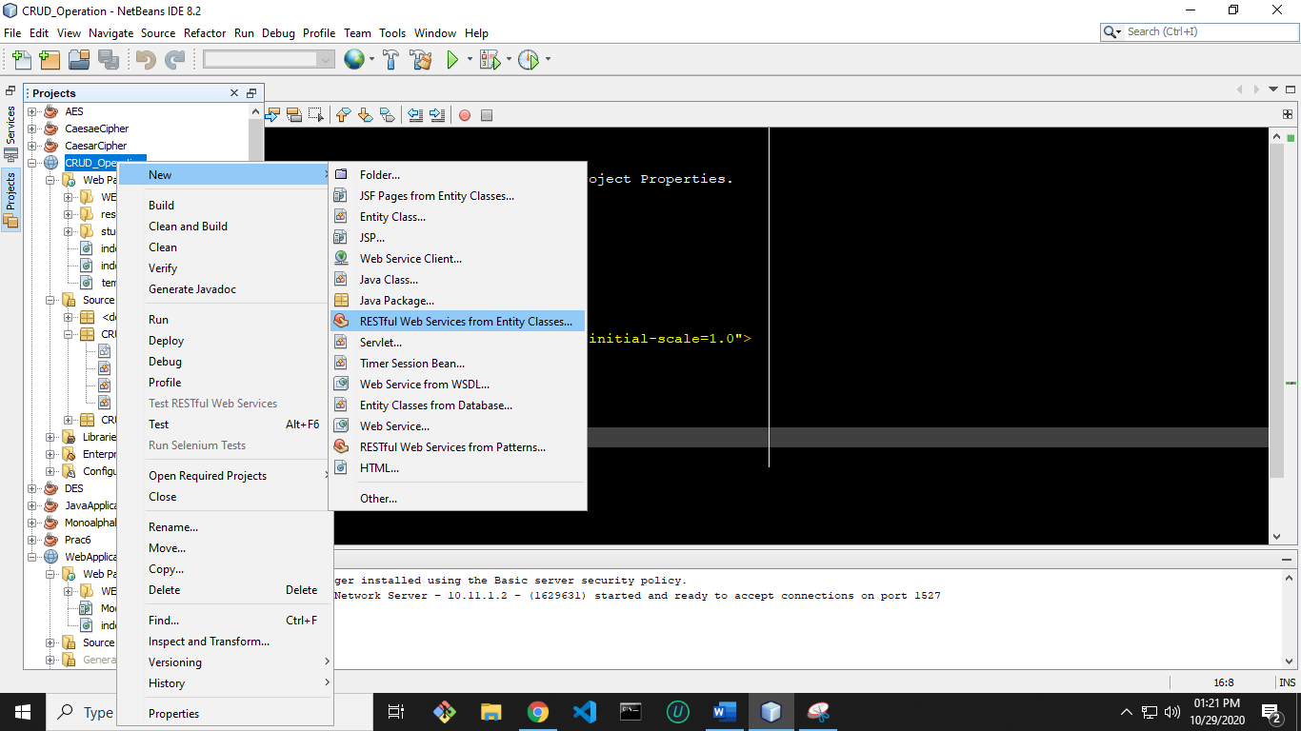

**12) Repeat step 9** and then it will go on next page. Then **enter the service** in

Resource Package and then **click on Finish button.**

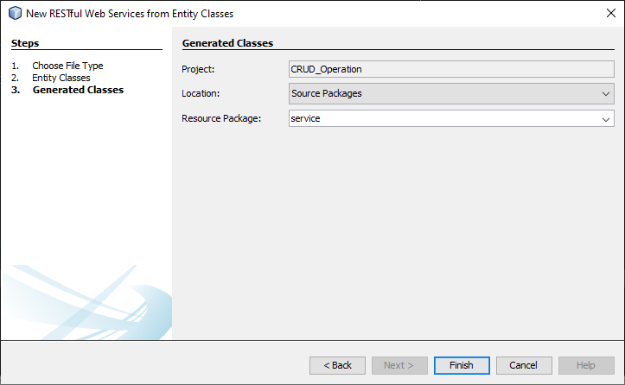

**13)** Now **open students.java file under wspract8 package.**

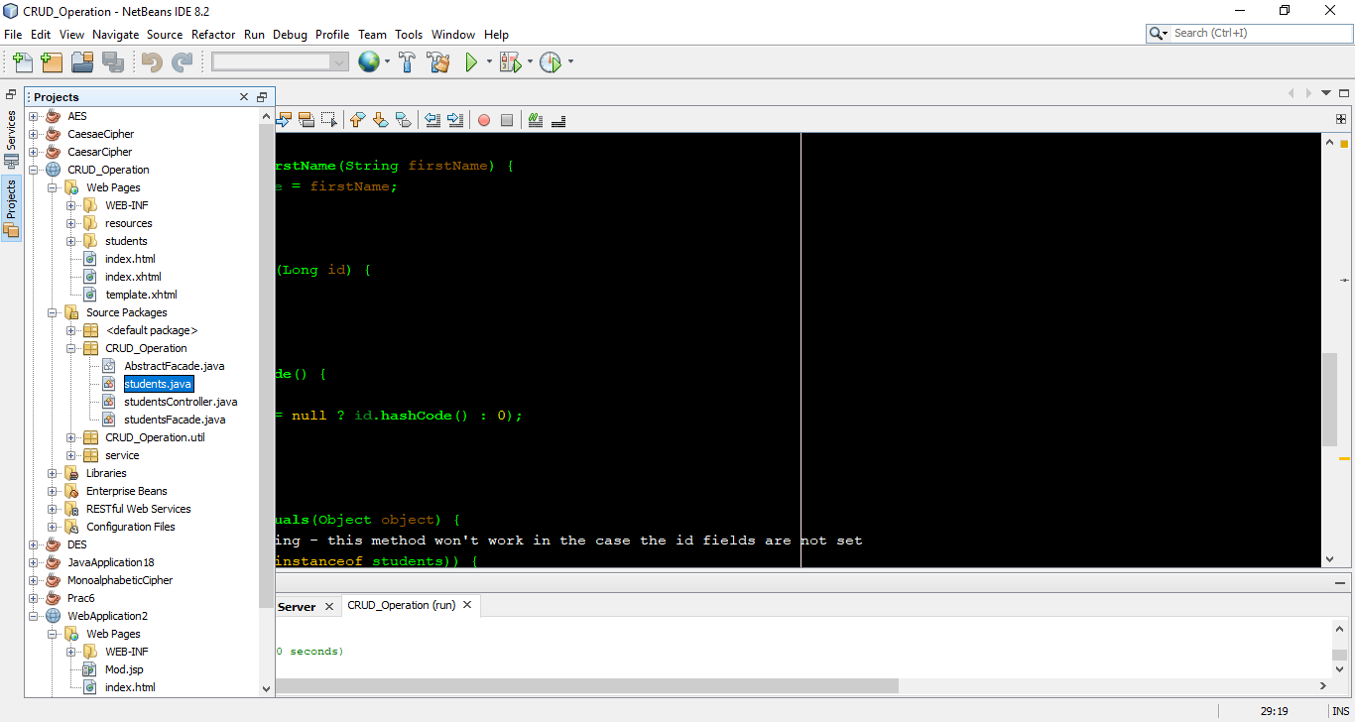

**14)** In this file **below line private Long id;** do the **right click and select Insert Code**.

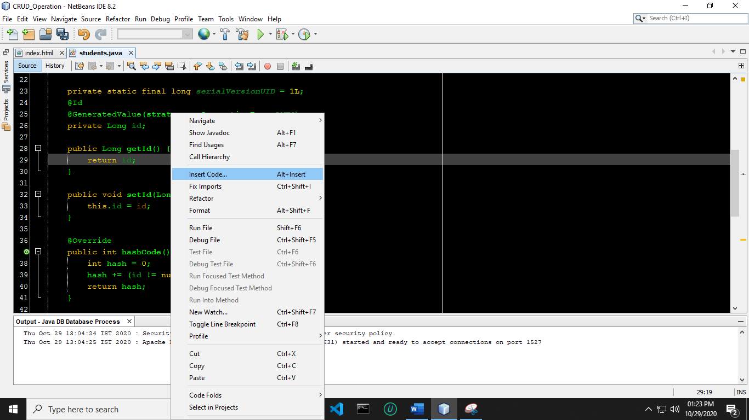

**15)** A new list will appear. **Click on Add Property**.

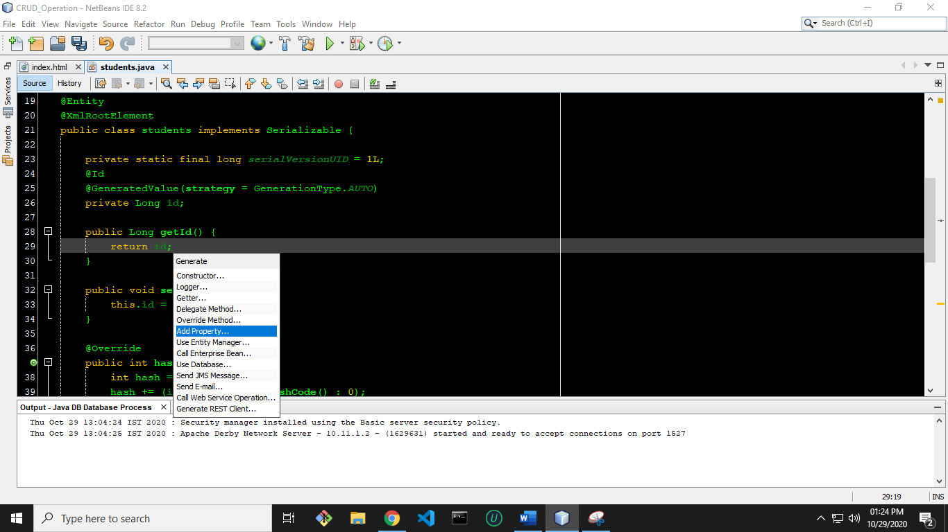

**16)** A new window will open. Enter name as **firstName**. Make sure name should be exact same as of mine and then **click on OK button**. Actually we are setting getter and setter method for firstName.

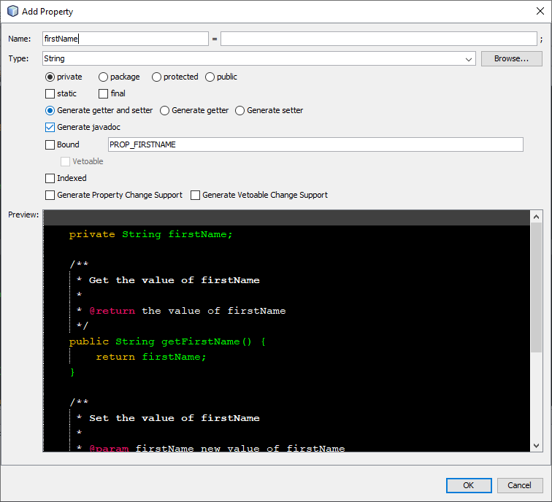

**17)** Now **right click on web application name and Deploy** it.

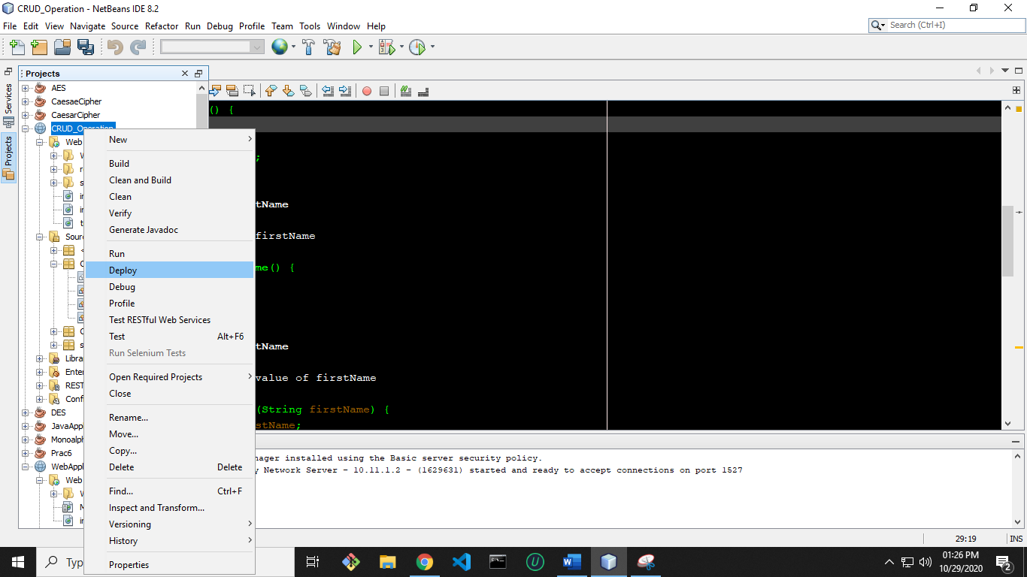

**18)** Now **right click on project name** and **run** it.

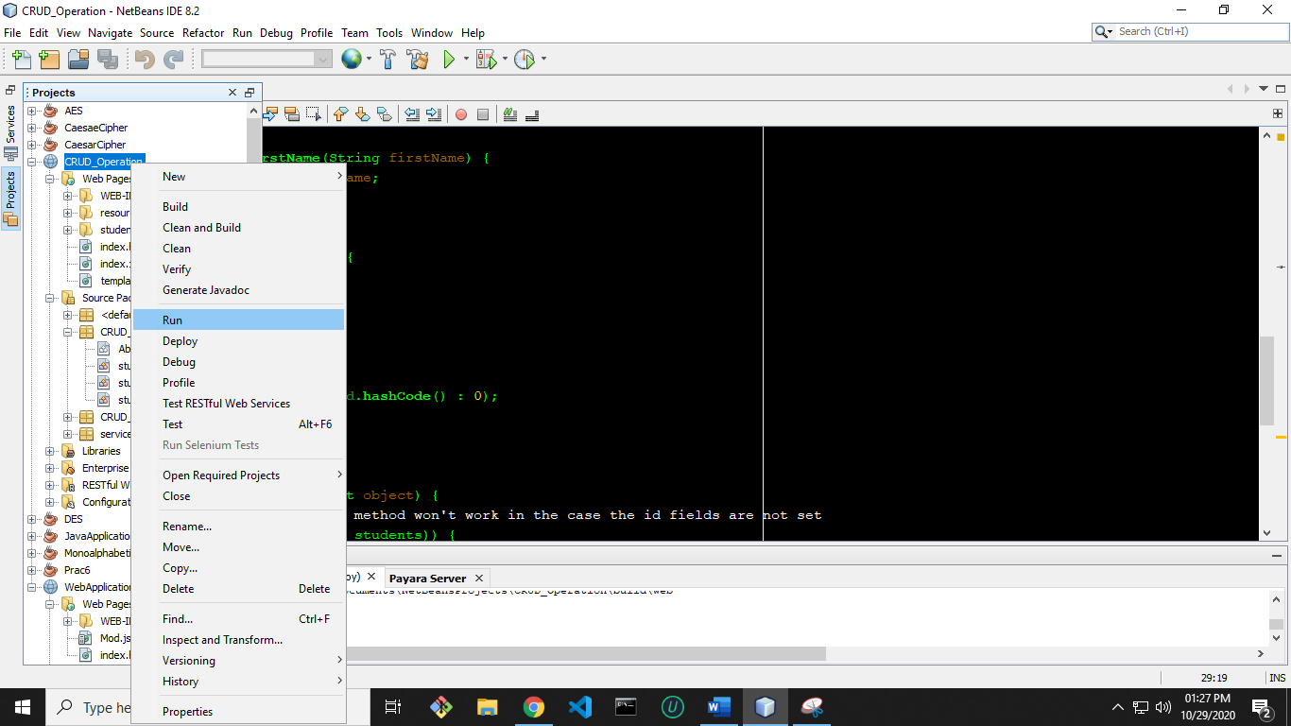

**19)** A window will open in browser like below.

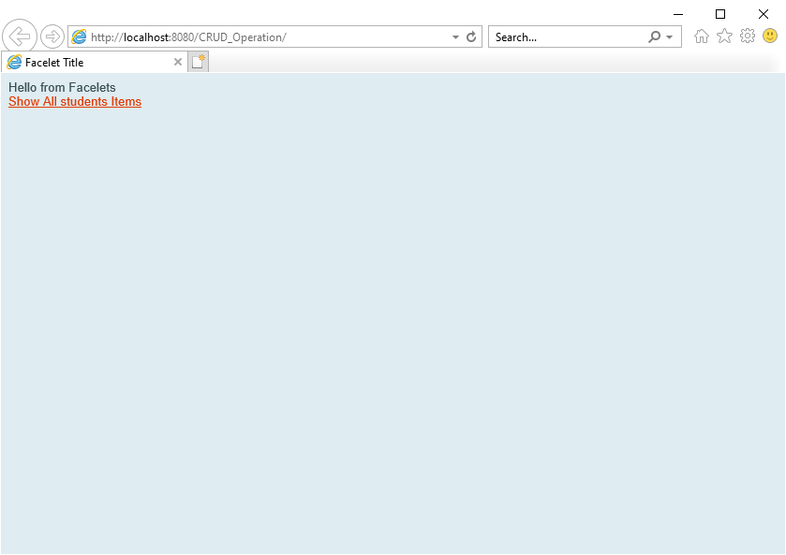

**20)** Now **click on Show All students** Items for CRUD operation.

Just click on Create New students. **Enter a name into FirstName and id into Id**. Now **click**

**on Save** option to savethe data.

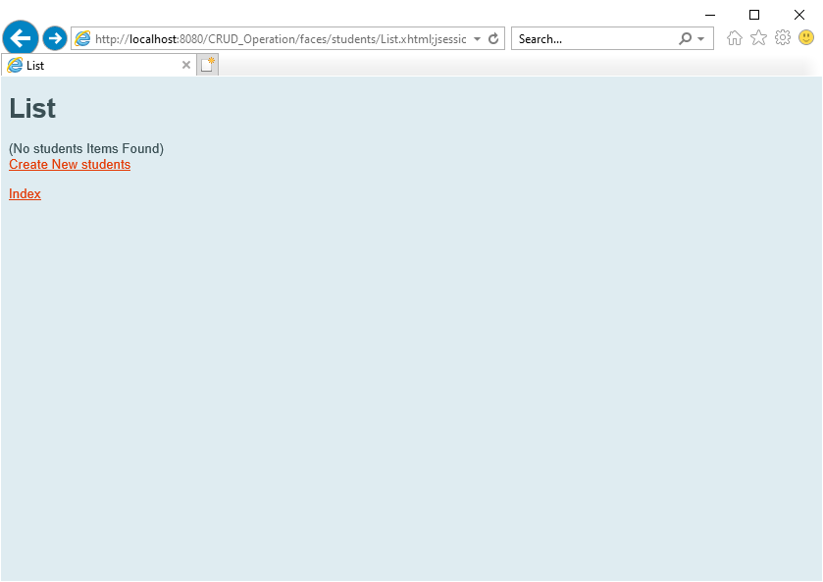

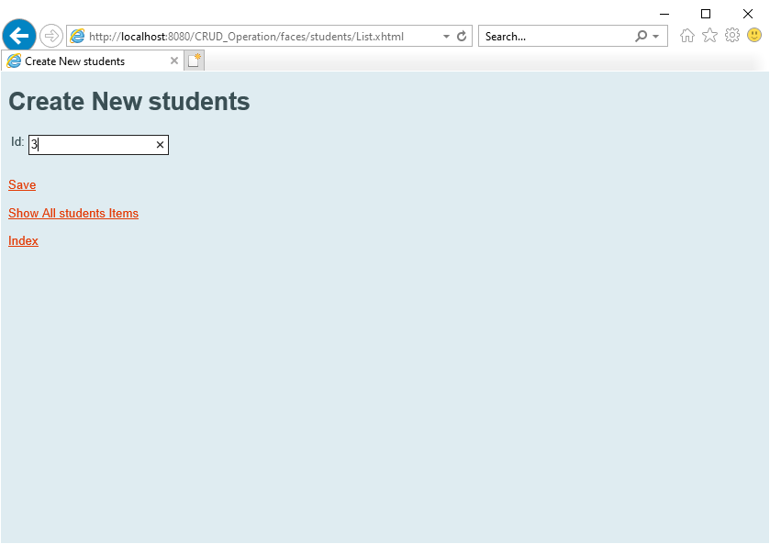

**21)** Now **click on Show All students Items to view all records** whether our data is

entered or not.

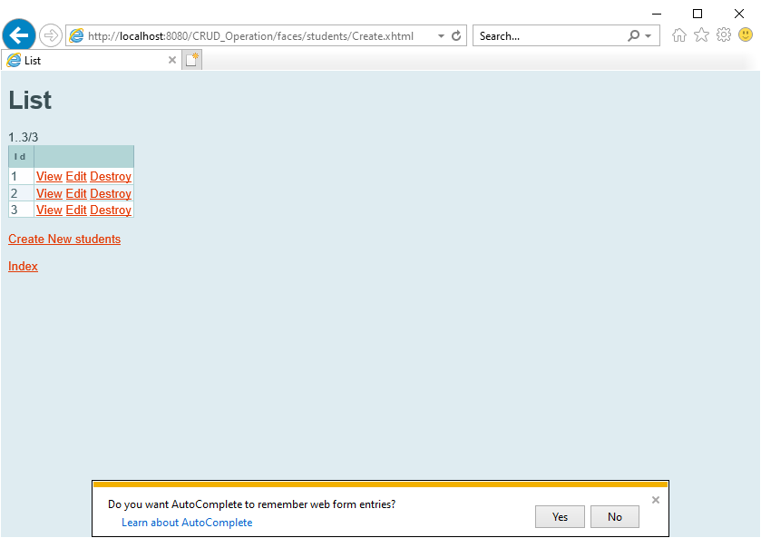

**22)** **Delete the Record**

